Student ID: 2404944
7CS039 Statistics for AI & Data Science

Introduction

In this report, I have performed an exploratory data analysis and measurements conducted in The University hospital of Odense during the period 1962 to1977. The dataset contains the variables which have been mentioned below,

Time: Time is a variable shows the days of survival after surgery.

Status: Indicates the patient status using indicators 1, 2, 3.

Sex: In the dataset male is indicated by while female by 0.

Age: The age of the patients at the time of operation.

Year: The time period of the observation.

Thickness: This variable thickness of tumor.

Ulcer: A categorical variable determine the presence or absent of ulcer.

Summary of Melanoma
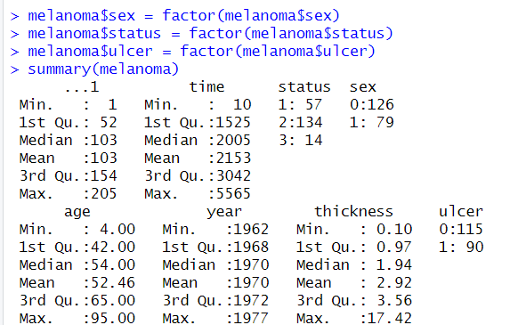

Time:- I examined that the duration of survival days was from 10 days to 5565 days.
Status: - This numerical value shows that
57 patient were died from melanoma, 134 stayed alive and 14 died from the other disease.
Sex: - we can see that the female patients were more than the male.
Age: - The numerical values of age shows that the minimum age of patient was 4 years and maximum age was 95 years who were suffered from that disease.[1]
Year: - Indicates the year at the time of disease.
Thickness: - I noticed that above numerical values told us the thickness of tumor after surgery.
Ulcer: - Ulcer was present in 90 patients and absent in 115.
Graphical Summary of Melanoma Variable
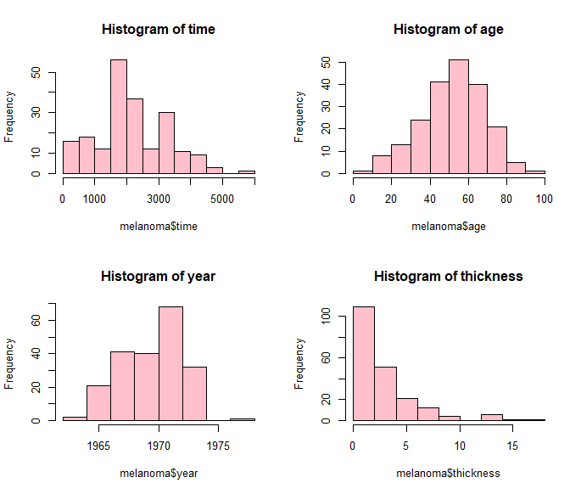
- Histograms.

After crafting histograms of melanoma variables which are displayed in the
above figures, I got an exillent idea of understanding dataset.
- Histogram of time shows that patients were alived maximum 1500 days approximately, after surgery and after 5000 days, the survival time was near to end.
- Histogram of age shows that most of the patient at the age of 60 suffered from that disease.
- Histogram of year tells us that in the year of 1970, the patient ratio was 70.
- Histogram of thickness indicates that thickness of ulcer,
maximum thickness of ulcer is 2.92.

Boxplots

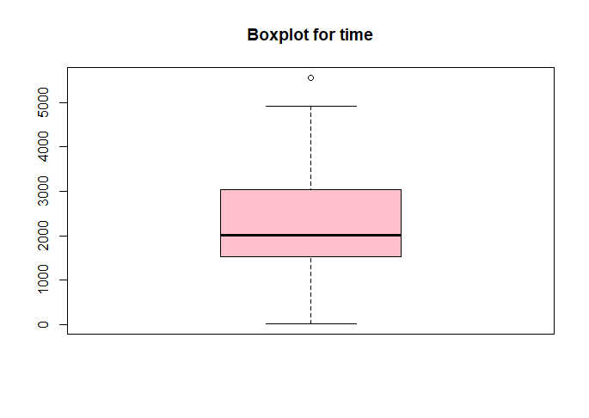
Boxplot for time.
It is clear from this plot the survival
more than 5000 days does not exist.

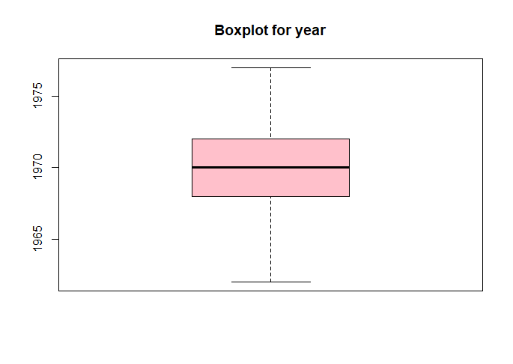
Boxplot for year.
Year is clear from chart in which
patients were examined at high rate.

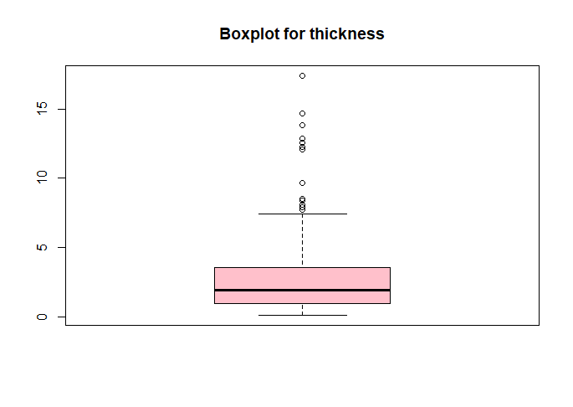
Boxplot for thickness.
The given plot indicates the thickness
of tumor clearly.

Correlation and Regression

Time ∼ Thickness:

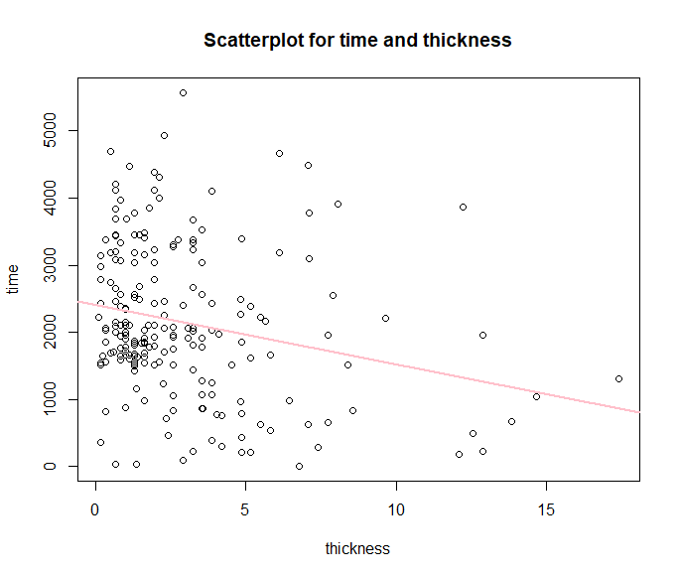

attach(melanoma)
library(tidyverse)
plot(thickness,time,main="Scatterplot for time and thickness",col="black")
LinReg <-lm(time ~ thickness)
abline(LinReg, col="red",lwd=2)
LinReg

Call:
lm(formula = time ~ thickness)

Coefficients:
(Intercept) thickness
2413.41 -89.25

cor(melanoma$time,melanoma$thickness,use="complete.obs")
[1] -0.2354087

Time ∼ Age

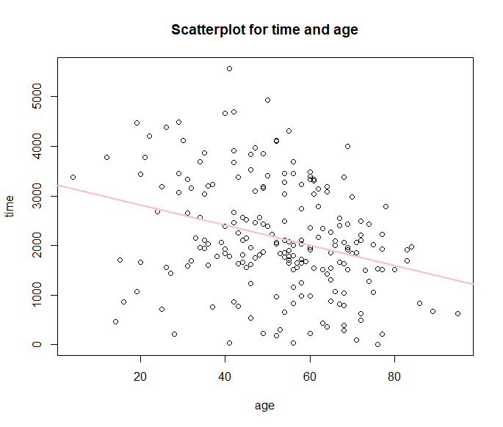

plot(age,time, main="Scatterplot for time and age", col="black")
LinReg <-lm(time ~ age)
abline(LinReg, col="pink",lwd=2)
LinReg

Call:
lm(formula = time ~ age)

Coefficients:
(Intercept) age
3217.45 -20.29
cor(melanoma$time,melanoma$age,use="complete.obs")
[1] -0.3015179.

Thickness ∼ Age.

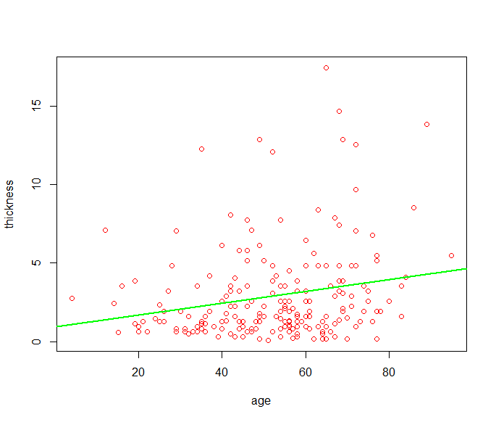

plot(thickness,age, col="red")
LinReg <-lm(thickness ~ age)
abline(LinReg, col="green",lwd=2)

LinReg

Call:
lm(formula = thickness ~ age)

Coefficients:
(Intercept) age
0.94105 0.03772
cor(melanoma$thickness,melanoma$age,use = "complete.obs")
[1] 0.2124798

# QQ-plot for time grouped by gender
qqplot_function(melanoma, "time", "sex", "QQ-Plot for Time"

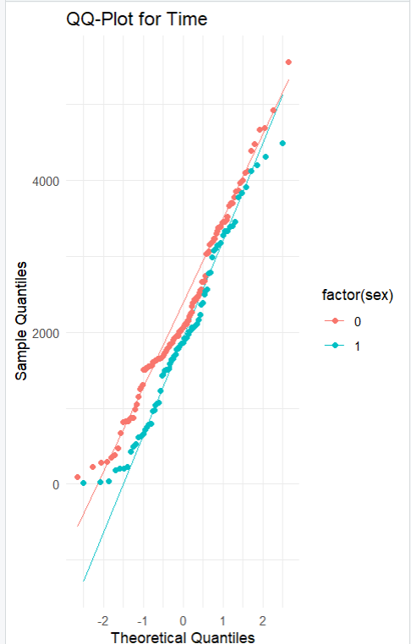

# QQ-plot for age grouped by gender
qqplot_function(melanoma, "age", "sex", "QQ-Plot for Age")

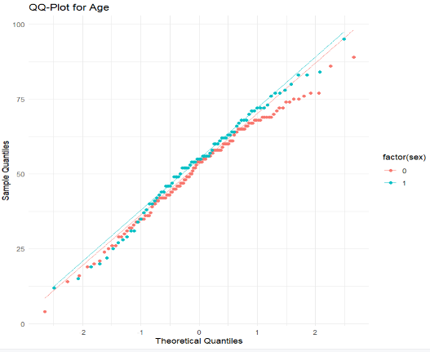

# QQ-plot for thickness grouped by gende
qqplot_function(melanoma, "thickness", "sex", "QQ-Plot for Thickness")

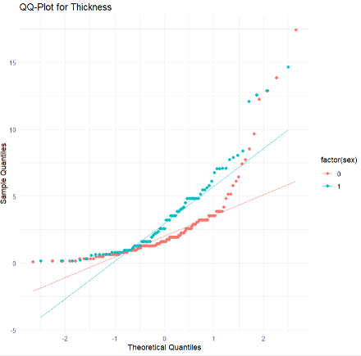
Explaination, .
All the QQplots are normaly distributed

After performing the above mentioned summaries, graphical techn iques, computaions and analysis from[1], I can say that it is the good experience of programming.The data is taken related to the given assessment and I tried my best to fulfill the requirements.

